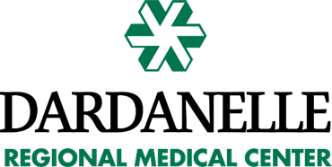

Financial Assistance – Plain Language Summary
The Dardanelle Regional Medical Center Assistance Policy exists to provide free or discounted care to eligible patients receiving medically necessary or emergent care. The full policy is summarized herein.
Eligible Services – Medically necessary and/or emergent healthcare services provided and billed by Dardanelle Regional Medical Center are eligible for financial assistance. Other services which are separately billed by other providers, such as physicians and laboratories, are not eligible for financial assistance under this policy. Elective procedures are not eligible for financial assistance under this policy.
Eligible Patients – Patients receiving eligible services, who submit a complete application for financial assistance form and are approved by Dardanelle Regional Medical Center. Patients may also become eligible for financial assistance based on medical indigence, medical hardship, or presumptive eligibility. These additional eligibility methods are documented in the full Financial Assistance Policy.
How to Apply – Application for financial assistance forms will be given to all uninsured patients and to anyone else upon request at time of admission. They may also be obtained at any point during the patient’s visit or during the billing process by contacting the Patient Financial Services Department at 479-229-4677. Forms can also be obtained from the Dardanelle Regional Medical Center website at http://www.dardanelleregional.org/Insurance. Completed forms and supporting documentation can be submitted in person to any member of the Patient Financial Services Department or mailed to:
Dardanelle Regional Medical Center
200 North 3rd Street
Dardanelle, AR 72834
Determination of Financial Assistance Eligibility – Eligibility for financial assistance will be determined by using the United States Department of Health and Human Services Federal Poverty Levels. Free care will be extended to applicants whose annual household income is less than or equal to 225% of FPL. Discounted care is based on a sliding scale to eligible applicants whose annual household income falls between 226% and 300% of FPL.
Note: If no household income is reported, information will be required as to how daily needs are met.

For help or questions please call Patient Financial Services at 479-229-4677.

